FOOD SECURITY/LIVELIHOODS PREPAREDNESS
RESPONSE

CLASSIFICATION OF FOOD SECURITY RISK LOCATIONS—USER GUIDE
Before the pandemic, this tool will help you:
- Classify target areas according to the risk of food and livelihood insecurity as the result of a severe pandemic.
- Identify areas where you will need to collect more information.
- Prioritize preparedness activities.
- Prioritize target areas in the municipality for prepositioning of aid.

During the pandemic, this tool will help you:
- Make decisions about the best use of food resources.

Who will implement this tool:
- The mayor
- The municipal leadership team

What You Should Know Before Using this Tool
This tool will not tell you exactly how many people in your municipality will suffer from food or livelihood insecurity during a pandemic. However it can provide you with an estimate of areas within the municipality that will be at highest risk during an influenza pandemic.

It is important to remember that all areas experience some level of risk. This tool provides a measure of the relative risk in one area of a municipality in relation to another area in the same municipality. Risk level is classified into three categories: high, medium, and low. The ranking is based on the risk of loss of income and the ability to secure enough food to keep all members of a household healthy during a severe influenza pandemic.
NOTE: This User Guide provides instructions for using the Classification of Food Security Risk Locations Excel Tool. For the Excel tool, please refer to the companion CD-ROM of this Toolkit.

How will the information in this workbook help Your TEAM?
This tool will help you to identify geographic areas that could become food insecure during a severe influenza pandemic. Classifying food security risk locations will help your team understand why certain areas should be prioritized for preventative action and response efforts.
Another function of this tool is to provide a perspective on the types of preparedness and response activities that may reduce risk and lessen potential impacts on a specific area or population. The tool can also help identify areas where your team may need to gather more information.

How to use this tool
- Enable Macros
This tool uses Microsoft Excel with the “Macros” function enabled. If prompted, click on “Enable Macros.” If you continue to have difficulty in using this Excel tool, please check your security settings.

To classify the risk level of target areas in your municipality follow these steps:

Step 1: Enter the Name of the Targeted Area
The first page you see when you open the tool will be a duplicate of the user’s guide. Hold the cursor over the button that says Use this Tool and click. A questionnaire will open.

Type the name of the targeted area. The targeted area can be a district, a village, or a dense urban zone within a municipality.

Step 2: Enter Information for each Risk Factor indicator
A series of questions ask about various food and livelihood security risk factors indicators. The answers to these questions will help you to identify geographic areas that could become food insecure as a result of a pandemic.

Where do I get the information to answer these questions?
Information sources will include existing data and expert knowledge. Once priority risk areas are identified it will be possible to conduct more detailed food and livelihood security assessments. Guidance on how to do this can be found in Tool 10: Identification of People Most at Risk of Food Insecurity.

If these assessments already exist, they are very good information sources. Ideally, all information should be at the chosen target area level. In the event that some information isn’t available at this level, the table on the following page lists potential sources for accessing information. Note that the links in the table will direct you to national-level data. This data should only be used if target area information is not available.

For accurate risk classification, it is essential to answer every question on the information entry form, so do your best to find out where you can get the information. However, some information about your municipality may not be immediately available. If this is the case, estimate what you don’t know to the best of your ability.

Bear in mind that if estimates are used in place of actual data, the results will be helpful as a graphic/numerical picture to help understand pandemic impact on food and livelihood security, however, these results should only be used for rough planning estimates until more accurate data are gathered within your municipality.

When entering data, use the arrows to enter percentages in increments of 5 % or you can type in a specific percentage such as 37%.

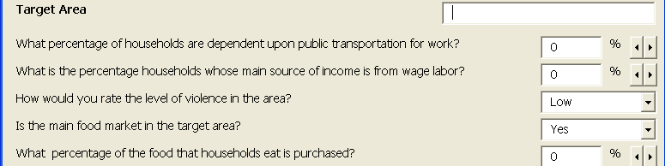

The following table provides possible sources of information that can help you to answer these questions.

Question | Possible Source of Information
What percentage of households must depend on public transportation to get to and from work? | Municipal or national transportation companies
What is the percentage of households whose main source of income is wage labor? | Data on formal and informal wage labor available from municipality and/or national governments
How would you rate the level of violence in the target area? (This is relative to other neighborhoods or villages in the municipality) | Expert local knowledge, police statistics, municipal or national governments
Is the main food market for households in the same targeted area?  (Households do not have to travel to distant markets in order to buy food) | Expert local knowledge
What percentage of food that households eat is purchased? | Municipal or national governments
What percentage of household income must be spent on food? | http://www.fao.org/faostat/foodsecurity/index_en.htm
What is the overall poverty rate for this area? | http://websie.eclac.cl/sisgen/ConsultaIntegrada.asp?idAplicacion=1
What is the percentage of stunting in children less than five years old?  Stunting means that children are short for their age. It is used as measure of poverty and hunger because it indicates that children have not had their basic food and nutrition needs met during their early years of life. | http://websie.eclac.cl/sisgen/ConsultaIntegrada.asp?idAplicacion=1
What percentage of the population does not eat enough to meet their basic energy needs?  You can find out more about basic energy needs in Tool 11: Household Food Security Preparedness and Tool 12: Distribution of Emergency Food during an Influenza Pandemic | http://www.fao.org/faostat/foodsecurity/index_en.htm (Depth of Hunger)
What percentage of households has access to health care?  Health care includes hospitals, clinics, health posts, private practices, or community health workers. | http://websie.eclac.cl/sisgen/ConsultaIntegrada.asp?idAplicacion=1
What percentage of households has access to improved latrines?  Improved latrines includes connections to public sewers or septic systems, flush latrines, and simple covered pit latrines, but does not include public or shared latrines, bucket latrines, or open pit latrines. | http://websie.eclac.cl/sisgen/SisGen_BadeinsoEnlaces.asp  http://www.depeco.econo.unlp.edu.ar/cedlas/sedlac/statistics.htm
What percent of households has access to water that is clean and safe to drink?  You can find out more about safe drinking water in Tool 11: Household Food Security Preparedness | http://www.depeco.econo.unlp.edu.ar/cedlas/sedlac/statistics.htm

Step 3: View Results
Risk Classification
When you are finished answering all the questions, click on the Generate Results button.
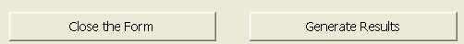

This takes you to a page of results that will look like the sample below.

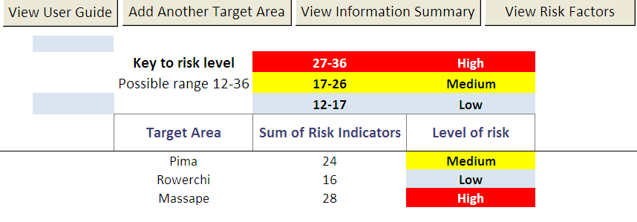
This button allows you to enter information for another target area.

The information you provide for each question (risk indicator) on the information entry form is given a risk value of one to three, with three being the highest risk. For example, if you indicate that in your municipality less than 15% of households use public transportation to get to work, a risk value of 1 is assigned to that question. If you indicate that more than 25% percent of households in your municipality are reliant on public transportation to get to work, the risk value assigned is 3. (Handout 1 shows how each risk value is calculated for each risk indicator).
Note that low risk is not the same as no risk. All areas will be at risk, but the classification system provides a way to compare the relative level of risk between areas.

The tool sums up all the risk values from the questionnaire. Based on the sum, the target area is assigned an overall level of risk, classified as low, medium, or high. Each risk level is color coded to provide a quick visual comparison between areas.

The range of possible sums is 12 to 36. Highest risk target areas are those that fall within the top 25 percent of possible scores (the score is greater than or equal to 27). Medium risk is assigned to areas with a score greater than or equal to (>=) 17 and less than 27. Low risk is assigned to areas with a total score >=12 and less than 17.

How can we organize this Risk classification INFORMATION?
Making a Risk Map provides your team with a graphic representation of the risk at the municipality level which can help you decide where to prioritize preparedness and response efforts.

Using the results shown on the Risk Classification Worksheet and a blank map of the municipality, create a map similar to the sample below by shading high risk areas red, medium risk areas yellow, and low risk areas blue.
High Risk
Medium Risk
Low Risk

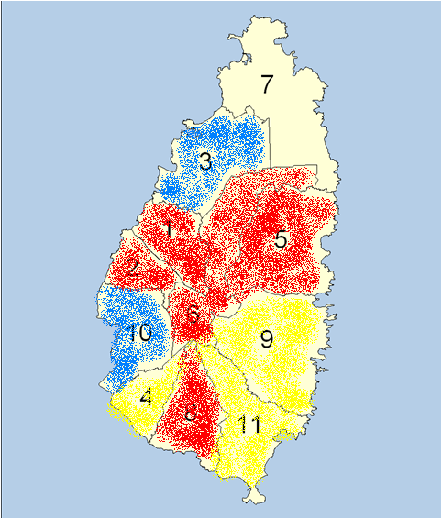

Step 4: View Risk factor results
Examining the level of risk assigned to each risk factor will help you to understand how each of the indicators (the questions from the information entry page) contributes to the overall risk of food and livelihood insecurity during a pandemic.

Hold the cursor over this button and click to view risk factors.

Sample Risk Factor page:

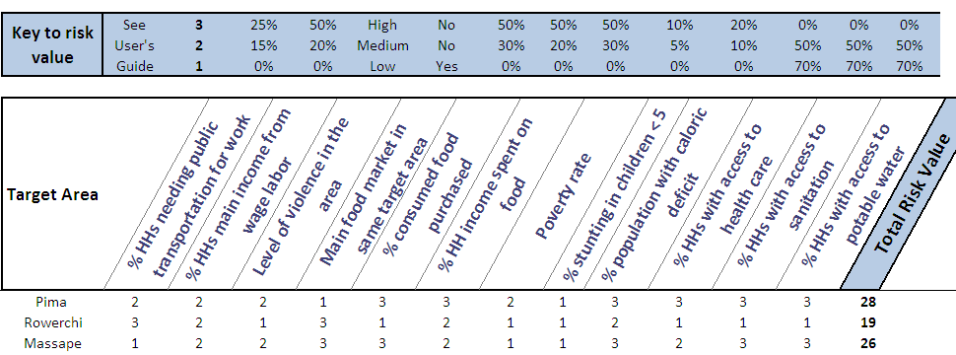

When a target area is assigned a risk value of three for a particular indicator, this suggests that this area is characterized by high risk for that indicator. If a target area is assigned a risk value of one, this suggests that this area is characterized by relatively low risk for that indicator.
The risk factor results help you to understand the main contributors to an area’s overall level of risk. This information helps you determine what types of preparedness and response activities might help lower the risk classification most quickly and what type of activities might not be appropriate for this area.

Using the sample Risk Factor Worksheet above, we see that in the target area of Pima six indicators are classified as high risk (Level 3): percentage of food purchased, percentage of household income that is spent on food purchases, percentage of people that do not meet their daily food energy needs (caloric deficit) and access to health care, sanitation services, and clean and drinkable water.

Because people are already food insecure in the community of Pima, emergency food distribution will probably be a necessary response during a pandemic. Looking further, we notice that a main food market exists in the area. If prices do not rise sharply and the market remains stocked, people may be able to obtain food during the early weeks of the pandemic. However, due to the fact that this target population purchases most of the food they eat (> 50%) and spends the majority of their income (> 50%) on food, if prices rise dramatically or markets run out of food, this community will suffer.

This information provides additional support for emergency food distribution as a response. It also alerts us that we must determine how much food is available in the area, so that we can plan for how much more we need to acquire. (For further guidance, turn to Tool 12: Distributing Emergency Food during an Influenza Pandemic.)

The sample data show that many households do not have access to health care, sanitation, or clean and drinkable water. This information alerts us that we must increase efforts to provide training in emergency response and home-based health care in this area. We will want to educate households about the need for increased hygiene, and will also want to ensure that households know how to purify water, and possibly provide them with water filters or household bleach if the municipal budget allows.

This tool cannot provide all the answers as to how your team can best protect the food security and livelihoods of the people in your municipality, but it can offer an initial understanding of why certain locations may need to be prioritized for preventative action and response efforts. Use the information that this tool provides as a guide to determining what type of in-depth information must be gathered using the other food security and livelihoods tools. By combining information gathered using the collection of tools, you will be better prepared to make the necessary decisions and take the critical actions that can reduce death and suffering in your municipality.

HANDOUT 1

Understanding Food Security And Livelihood Risk Classification

The calculation of the risk values is shown in the following table. It is also provided at the top of the Risk Factor worksheet in the Excel tool.

Question from Information Entry form (risk indicator) | Indicator values | Risk values
What percentage of households must depend on public transportation to get to and from work? | < 15%  >=15 %and < 25%  >=25% | 1  2  3
What is the percentage of households whose main source of income is wage labor? | < 20%  >=20 % and < 50%  > =50% | 1  2  3
How would you rate the level of violence in the neighborhood? (This is relative to other neighborhoods or villages in the municipality) | Low  Medium  High | 1  2  3
Is the main food market for households in the same targeted area? | Yes  No | 1  3
What percentage of food that households eat is purchased? | < 30%  >=30 % and < 50%  > =50% | 1  2  3
What percentage of household income must be spent on food? | < 20%  >=20 % and < 50%  > =50% | 1  2  3
What is the overall poverty rate for this area? | < 30%  >=30 % and < 50%  > =50% | 1  2  3
What is the percentage of stunting in children less than five years old? | < 5%  >=5% and < 10%  > =10% | 1  2  3
What percentage of the population does not eat enough to meet their basic energy needs? | < 10%  >=10 % and < 20%  > =20% | 1  2  3
What percentage of households has access to health care? | >=70%  <70% and >= 50%  <50% | 1  2  3
What percentage of households has access to improved latrines? | >=70%  <70% and >= 50%  <50% | 1  2  3
What percent of households has access to water that is clean and safe to drink? | >=70%  <70% and >= 50%  <50% | 1  2  3

